3. Waterfront Living in Naples: What Buyers Should Know Before Purchasing

SEO Title
A Buyer’s Guide to Waterfront Homes in Naples Florida

Meta Description
Learn what luxury buyers should know before purchasing waterfront property in Naples, including boating access, dockage, exposure, and construction considerations.

Target Keywords
Naples waterfront homes, buying waterfront property Naples FL, Port Royal waterfront homes, Naples boating homes

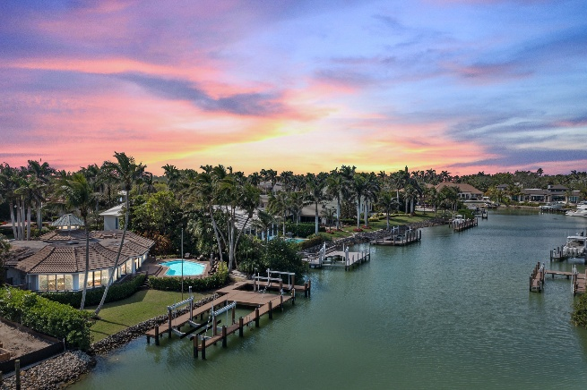

Internal Linking Opportunities
- Waterfront property search page
- Port Royal listings
- Aqualane Shores homes page

Suggested CTA
Searching for the ideal waterfront property in Naples? Contact Michael Giacalone at Premier Sotheby’s International Realty for private market insights and available listings. 239.431.0321

A Guide to Coastal Luxury Real Estate
Waterfront living is one of the biggest reasons buyers choose Naples, but purchasing a waterfront property involves more than simply finding a beautiful view.
In neighborhoods like Port Royal, Aqualane Shores, and Royal Harbor, buyers should evaluate several important factors before making a purchase. Water depth, dockage capabilities, bridge access, seawall conditions, and boating proximity to the Gulf can all impact the value and functionality of a property.
For boating enthusiasts, quick Gulf access is often a top priority. Some homes allow direct deep-water access with no bridges, while others may have limitations depending on vessel size. Understanding these details early in the buying process can help ensure the property aligns with a buyer’s lifestyle.
Another important consideration is lot orientation. Western-facing homes often provide stunning sunset views, while southern exposure can maximize natural light throughout the day. Outdoor living spaces, pools, summer kitchens, and expansive lanais also play a major role in how homeowners experience waterfront living.
Buyers should also pay attention to construction quality and elevation. Many newer luxury homes in Naples incorporate advanced building standards, impact-resistant materials, elevated foundations, and smart-home technology.
Perhaps most importantly, waterfront real estate in Naples is about lifestyle. It means waking up to water views, enjoying boating adventures within minutes, and entertaining family and friends in one of the most beautiful coastal settings in the country.
With the right guidance and market expertise, buyers can find a property that not only meets their needs today but also becomes a lasting investment for years to come.

